**Propero discounting app Low level requirement or Project Charter**

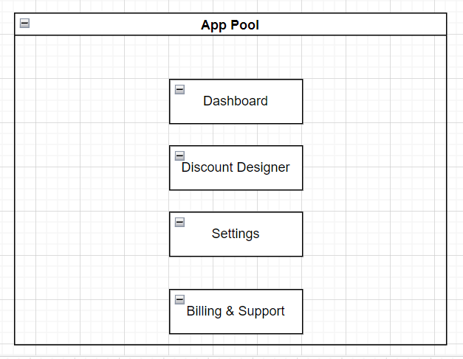**Basic Architecture of Discounting App**

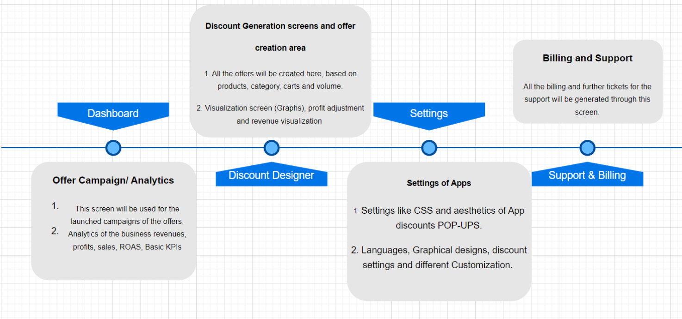

**Main Frames:**

1. Dashboard
2. Discount Designer
3. Billing
4. Settings
5. Support

* **Discount Designer:**

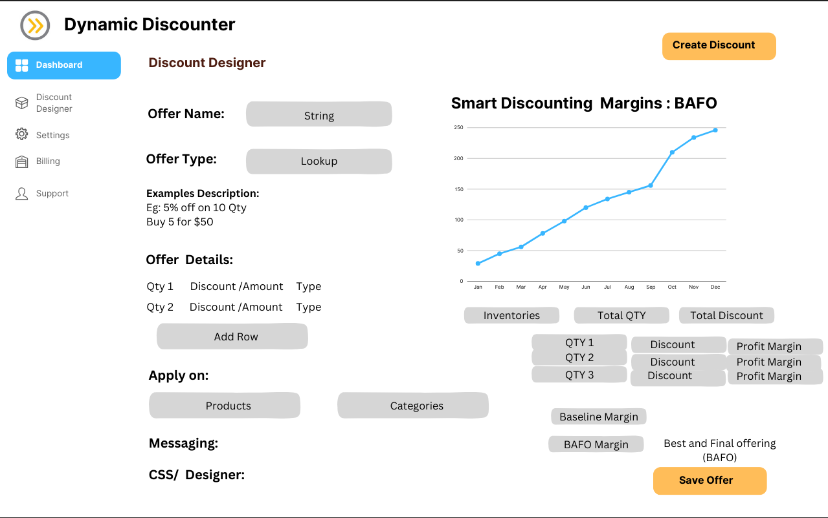

* **Detailed Attributes:**

|  |  |
| --- | --- |
| **Attributes name** | **Type** |
| **Offer name** | **String** |
| **Offer type** | **Lookup** |
| Explanation description | Description in built (pre-defined) |
| **Offer details** | **Table / Row addition architecture** |
| Qty (Quantity) | Numerical |
| Discount (%) or amount | Numerical |
| **Type** | **Lookup** |

**A cancel Button will also be added besides the save offer button**

* **Discount Types**
* Volume discount
* Spend amount discount
* Buy X for $
* Free Shipping
* **Offer Type:**
* Volume Discount:

***Example:***

* Buy 5 or more - get 10% Off
* Buy 10 or more - get 20% Off

**Offers details Tab:**

A customizable table to be created 🡪 **Table frame**

|  |  |  |
| --- | --- | --- |
| Qty 1 | Discount / Amount | Type |
| **Numerical** | **Numerical / decimal** | **Lookup** |

Button to be added for the addition in the time frame

Add Row

Type: **Lookup** 🡪 % off each (Percentage)

$ Amount off each (Decimal)

$ each

* Spend Amount discount

***Example:***

* Spend over $ 400 on the Summer Collection - get 20% off each Summer Collection item
* Spend over $ 100 on Sneakers - get $ 5.00 off the order

|  |  |  |
| --- | --- | --- |
| Minimal Ticket Size (Sales) | Discount / Amount | Type |
| **Numerical** | **Numerical / decimal** | **Lookup** |

Add Row

Type: **Lookup** 🡪 % off each (Percentage)

$ Amount off each (Decimal)

$ each

* Buy X for $ (BOGO offerings)

***Example:***

* 3 items from the Summer Collection for $ 10.00
* 2 shoes for $ 10.00

|  |  |  |
| --- | --- | --- |
| Qty | Discount / Amount | Type |
| **Numerical** | **Numerical / decimal** | **Lookup** |

Type: **Lookup** 🡪 % off each (Percentage)

$ Fixed amount on the quantity

$ Fixed amount Per Item

* Free Shipping

***Example:***

* Get X Qty to get the free shipping option

|  |  |
| --- | --- |
| Qty | Free Shipping |
| **Numerical** | **Enabled tab or a check box** |

* **Apply On:**
* **Products**
* **Category**

**Category Frame**

**Product Frame**

* **PRODUCTS**: Drop down List of the Products of the websites with multiple selection on which the offer can be applied.

🡪 *a check box to apply the offers on all products*

* **CATEGORY**: Drop down List of the Categories of the websites with multiple selection on which the offer can be applied.
* **Messaging:** to be decided
* **CSS:** to be decided

**Graphical UI:**



* **Data Visualization:**

Creation of the UI screen by the side, in Finalization screen.

An inventory tab to be added in which the product inventory to be added with the Base price.

**Updation after date 7th feb 24 sprint meet**

**Screen 1**

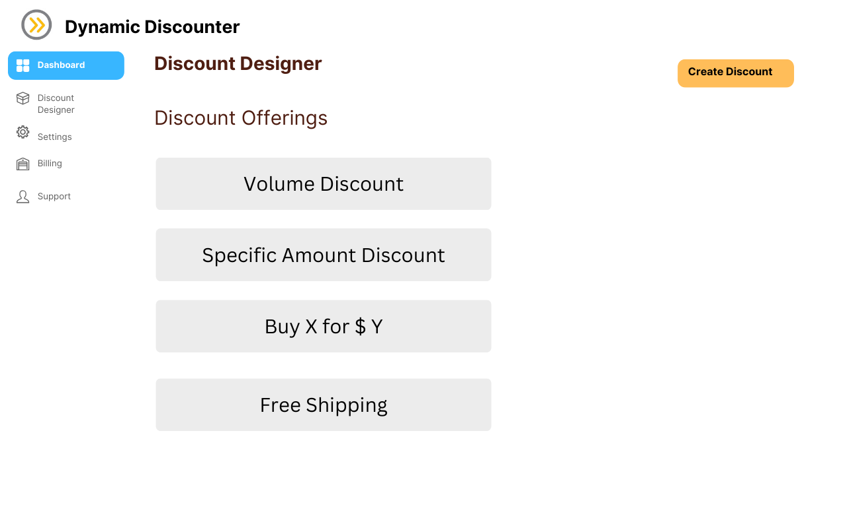

Step 1: Merchants can have a feasibility to click the discount offerings and after clicking on any of the offering types, e.g. volume discount.

After clicking on it. ..

Step 2: The main screen will get opened with the filled offer type as clicked by the merchant.

